I partners

Coordinatore europeo: | Oonagh Mc Nerney  Iberian Productivity and Innovation Centre, Spain  E-mail: omcnerney@ipic.cat  Tel: + 34 652839215
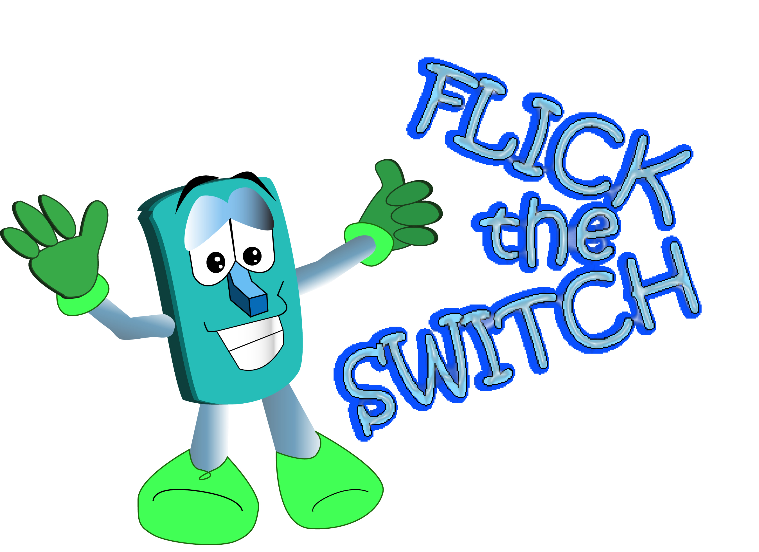
Coordinatore nella Provincia di Perugia | Agenzia per l’Energia e l’Ambiente della Provincia di Perugia  Str. Corcianese, 218 06070 PERUGIA  Persona di riferimento: Francesca Pignattini  e-mail: info@aea.perugia.it Tel. 0039 075 5170824  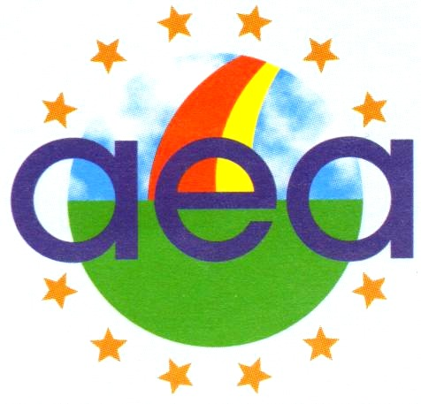
  Altri Partners europei : | Projects in Motion Ltd., Malta  University of Zagreb, Faculty of Mechanical Engineering and Naval Architecture, Croatia  Climate Energy Ltd., United Kingdom  Western Education & Library Board, Northern Ireland  PPS Karmoy, Norway  RAKVERE Gumnaasium, Estonia  Kuršėnai Pavenčiai Secondary School, Lithuania  Istituto Comprensivo Statale - Gagliano Del Capo (Le), Italy  Rakvere Linnavalitsus (Rakvere City Government), Estonia

